Press release

Under embargo: not for broadcast or publication until Monday 11th December 2023
14:00 GMT / 15:00 CET / 19:00 UZT / 20:00 ALMT / 22:00 MNT
“Unprecedented conservation triumph”:
Saiga antelope reclassified from ‘Critically Endangered’ to ‘Near Threatened’ in the IUCN Red List of Threatened Species
This significant positive status change reflects the species’ remarkable recovery in Kazakhstan resulting from sustained ongoing conservation efforts, but action is still needed to ensure populations continue to improve across the species’ range

Today [11th December 2023], the IUCN Red List status assessment of Saiga antelope (Saiga tatarica) has been changed from Critically Endangered to Near Threatened, thanks to effective national and international conservation efforts.

This substantial positive change in global Red List status – a rarity in conservation – reflects the remarkable recovery of saiga populations in Kazakhstan, which have recovered from a perilously low estimate of just 48,000 in 2005 to now over 1.9 million.

This triumph is thanks to significant conservation efforts over nearly two decades by Kazakh and other range state governments, research organisations, national and international NGOs, including the Saiga Conservation Alliance, the Altyn Dala Conservation Initiative - Altyn Dala means Golden Steppe in Kazakh - (comprising the Government of Kazakhstan, the Association for the Conservation of Biodiversity of Kazakhstan [ACBK], Fauna & Flora, Frankfurt Zoological Society, the RSPB), NABU, the Wildlife Conservation Society and WWF-Mongolia. Long term support from donors has been vitally important.

The Government of Kazakhstan has demonstrated highly commendable leadership in species recovery, investing heavily in a suite of impactful actions including anti-poaching initiatives, robust law enforcement and border control measures, and establishment of a series of major new State Protected Areas. Its enduring collaboration with civil society partners has played a crucial role in fostering a collaborative network that incorporates government agencies, conservation practitioners, academics, and international experts, and today's celebration of success is a culmination of everyone’s efforts.

The Convention on the Conservation of Migratory Species of Wild Animals (CMS) has played a crucial role in bringing governments and civil society organisations across the saiga range together, to agree on and then implement an International Work Programme on the Conservation and Sustainable Use of the Saiga Antelope, in coordination with the Convention on International Trade in Endangered Species of Wild Fauna and Flora (CITES).

Under this Work Programme, the partners have together supported governments’ implementation of anti-poaching and law enforcement measures, formally protected key saiga habitats and monitored populations, whilst also working with local communities to raise their awareness of the issues facing saigas and to form community-led ranger teams.

Such an improvement in status shows that conservation and management measures are working and must continue. Yet despite this good news, conservation action is still urgently needed to ensure that saiga antelope has a long-term sustainable future in Kazakhstan, and to ensure that the smaller populations recover in Mongolia, the Russian Federation and Uzbekistan. Current population numbers for saiga in Russia are 38,000, up from 4,500 in 2016, while Uzbekistan hosts an estimated 500 saiga, c.200 of which were first discovered in the Aral Sea Region in 2021 whilst the remaining 300 are isolated by human-made barriers to migration. In November 2023 a census of the Mongolian subspecies reported a population number of 15,540 individuals. There have been no instances of poaching since 2018, when the population level was 3391.
The species will only be fully recovered if it regains its role in the ecosystem across its entire range, with ongoing poaching, illegal trade, disease, climate change, disturbance and infrastructure development all posing a threat to saiga. The species’ new Near Threatened category reflects the potential for its status to deteriorate rapidly in the absence of ongoing conservation action. The commitment from the conservation community is unwavering in its support to this iconic species.

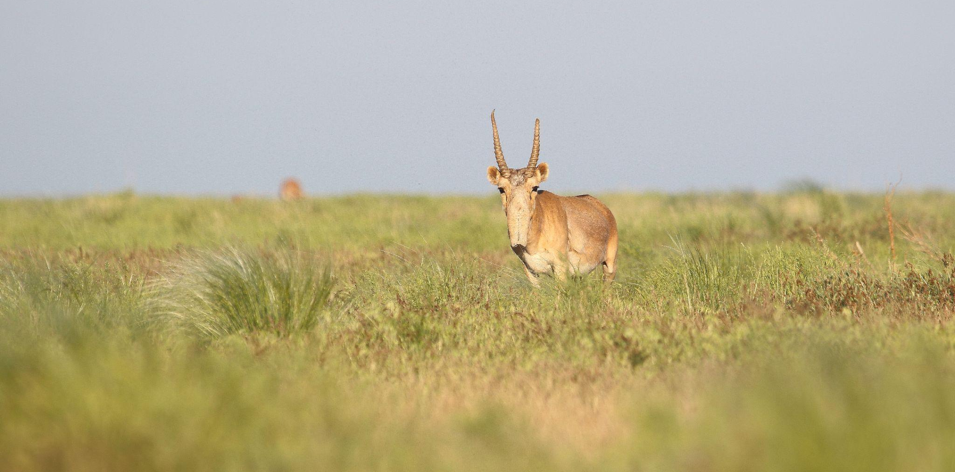
A male saiga in Ural, May 2019 (c) Albert Salemgareyev

Professor E.J. Milner Gulland, Oxford University, Co-Founder and Chair of the Saiga Conservation Alliance explains: “This brilliant news is the culmination of decades of collaborative work by national and international level organisations across the whole saiga range, including governments, NGOs and academics. It shows how conservation can be effective if all parties work together, with a strong mission and appropriate resourcing.
It’s been the greatest privilege and honour for me to work alongside so many passionate conservationists over the years; the work is not finished, because there are still many threats that need to be addressed if the saiga is to recover and thrive across its whole range. But I am confident that we can get to a future in which the saiga has regained its rightful place within its ecosystems, as a component both of the natural world and the region’s culture and livelihoods.”

Vera Voronova, Executive Director from ACBK, talking on behalf of the Altyn Dala Conservation Initiative, adds: “As one of the most successful recoveries of a terrestrial mammal ever recorded, this is a significant milestone for the saiga antelope conservation community and illustrates how conservation can be effective if all parties collaborate with a strong mission and appropriate resourcing. We need to ensure that conservation action scales up across Kazakhstan and neighbouring countries more broadly, to ensure the long-term recovery of saiga antelope in all range states. We look forward to seeing the sustainable future of the species alongside other native wildlife to benefit steppe grassland ecosystem restoration and rural communities’ livelihoods.”

Amy Fraenkel, Executive Secretary of the Convention on the Conservation of Migratory Species of Wild Animals, states: "The remarkable recovery of the Saiga antelope underscores the importance of international cooperation for the conservation of migratory species. The improved conservation status of the Saiga, from Critically Endangered to Near Threatened, demonstrates how the collective efforts of governments, scientific experts, conservation organizations, local communities, intergovernmental bodies and other stakeholders can turn the tide on extinction. Yet, as we celebrate this success, we need to continue significant conservation efforts for the Saiga, which is highly susceptible to sudden changes, and whose recovery is not uniform across its range. I am confident that the work of CMS, all of the Saiga range states, and the many entities committed to Saiga conservation will continue to achieve positive results for this treasured species.”

Further information

The IUCN Red List of Threatened Species is the authoritative global list of the conservation status of the world’s species, which is used globally to support conservation efforts, including as a headline indicator of progress in conservation action for the Convention on Biological Diversity. It includes an assessment of the threat of extinction faced by a species, sub-species and at the national level, and also a Green Status score for the impact of conservation action and prospects for recovery.

Saiga antelopes have roamed the earth since the last Ice Age, outliving iconic extinct species like woolly mammoths and sabre-toothed tigers, and play a crucial ecosystem role as a selective grazer, influencing vegetation structures, distributing nutrients, and in turn, supporting biodiversity across its habitat. There are two sub-species, Saiga tatarica tatarica (found in most of the range) and Saiga tatarica mongolica (found only in Mongolia). Despite once migrating through eastern Europe, Asia and Alaska, they are only currently found in fragmented populations across Eurasia, within Kazakhstan, Mongolia, the Russian Federation and Uzbekistan. There were an estimated 1 million saigas in Russia and Central Asia in the early 1990s, but by 2003 their numbers had plummeted, with only 6% of the population remaining.

The reasons for the decline are complex. Decades of uncontrolled criminal poaching for meat and horns (exported for the belief-based medicine trade in Asia), since the break-up of the former Soviet Union, led to the catastrophic fall in numbers. This, combined with the increasing development of linear and extractive infrastructure with its consequential habitat fragmentation, along with continuing illegal trade and demand in consumer countries, all combined with climate change, has spiralled the species into further decline.

Yet, despite these alarming statistics and ongoing threats, there is clear hope. In response to the species' plight, governments, academic institutions and international and national conservation organisations have come together to restore the saiga population, supported by the UN Conventions CMS and CITES. The CMS Memorandum of Understanding concerning Conservation, Restoration and Sustainable Use of the Saiga Antelope (Saiga MOU) was established in 2006 and signed by all Saiga Range States. Since then, the CMS Secretariat has facilitated the development of science-based and internationally agreed conservation measures for the Saiga Antelope, which are contained in the regularly updated Medium-term International Work Programme for the MOU. The Work Programme provides a framework and aims to ensure a careful balance is met between species recovery and the impact on local communities.

The saiga conservation community has delivered a series of successful conservation interventions resulting in the boom in Kazakhstan’s saiga population seen today, and improvement in the status of the species across its range. Multiple State Protected Areas covering over 5 million hectares have been established, most recently the 657,450 hectare Bokey Orda-Ashiozek Protected Area in Western Kazakhstan, and comprehensive research and monitoring to assess the species’ populations, abundance, ecology and migration routes, and efforts to tackle poaching, are all ongoing.

This nuanced picture is reflected in the saiga’s Green Status of Species score, which is “Largely Depleted”. This highlights that saigas are not yet playing their full role in the ecosystem across their whole range, despite impressive conservation efforts. However the species’ Green Status also demonstrates that there is excellent potential for further recovery if conservation efforts are continued and intensified, range-wide.

The published saiga assessment on the Red List website can be found here from the afternoon of 11th December: https://www.iucnredlist.org/species/19832/233712210

The details on the saiga’s Green Status can be found here: https://www.iucnredlist.org/species/19832/50194357

To find out more about ongoing saiga antelope conservation work across all range states in Central Asia, visit: www.saiga-conservation.org and www.altyndala.org

- ENDS -

Photos and Footage

For high-resolution royalty free images and video, interview requests, or further information, please contact: Stephanie Ward: ward@zgf.de, +447704905866
For images and film, see here (credit lines can be found within the file names): https://drive.google.com/drive/folders/1KsZgqyQHYYVFcwPsaFmaOcYNuCp_iPRi?usp=sharing
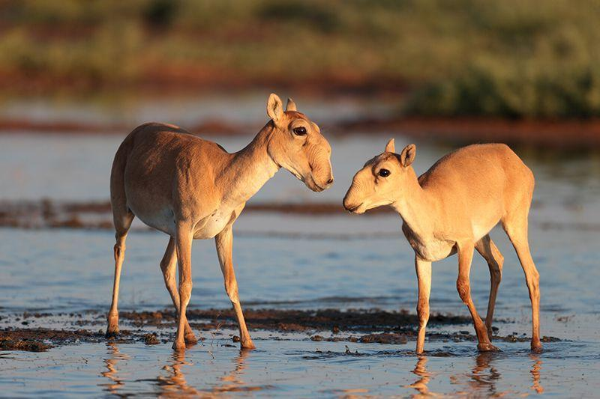

Female saiga antelope with her young. Credit Eugeny Polonsky. [High-res version, and others, are available]

Notes to Editors

AVAILABLE FOR INTERVIEW

- Professor E.J. Milner Gulland, University of Oxford, Co-Founder and Chair, Saiga Conservation Alliance, e: ej.milner-gulland@biology.ox.ac.uk, t: +44 7528369932

- Vera Voronova, Executive Director, Association for the Conservation of Biodiversity of Kazakhstan e: vera.voronova@acbk.kz t: +7 701 266 3253 (international enquiries NB: Vera will be at UNFCCC COP28 until 12th December for interviews )

- Alyona Krivosheyeva, Conservation Director, Association for the Conservation of Biodiversity of Kazakhstan e: alyona.krivosheyeva@acbk.kz t: +7 701 369 7146 (enquiries in Kazakhstan)

- Contact: Aydin Bahramlouian, Public Information Officer, Secretariat of the Convention on Migratory Species, t: +49 (0)228 815 2428, e: press@cms.int
- Contact: Joanna Colley, Media Relations Manager, Fauna & Flora e: Joanna.Colley@fauna-flora.org t: +44 (0) 7818040144
- Contact: Dagmar Andres-Brümmer, Head of Communications Department, Frankfurt Zoological Society e: andres-bruemmer@zgf.de t: +496994344612

- Contact: Becca Smith, Media Officer, Royal Society for Protection of Birds,
e: pressofficelodge@rspb.org.uk t: 0300 121 0475

- Contact: Katja Kaupisch, Team Leader of the Central Asia and Eastern Europe Programme, NABU, e: katja.kaupisch@nabu.de,

- Contact: M Dixon, Press Office, Wildlife Conservation Society, t: +1 347-840-1242 e: mdixon@wcs.org

ADDITIONAL PARTNER QUOTES

David Gill, the Fauna & Flora’s Director of Operations for Eurasia, says: "The improvement in conservation status for saiga is truly a landmark moment for the species, and represents an incredible team effort and investment from the national governments and NGO partners working across the range. At Fauna & Flora we're humbled and proud to have been right behind the efforts of our local partners who have been best placed to lead this incredible recovery. Over the last 15 years, we've together been through many ups and downs for the species, but the latest news really is a monumental moment. Knowing how vulnerable the species can be to threats, it's important now that we maintain this momentum, and ensure that saiga continues to be a major conservation success story for the coming decades."
Michael Brombacher, Head of Europe Department, Frankfurt Zoological Society says: “We are delighted to be able to celebrate this great moment for saiga conservation. FZS is proud to have been part of the dedicated efforts of the saiga conservation community and we look forward to continuing this important steppe restoration work into the future to ensure these great strides continue.”
Katie-Jo Luxton, the RSPB’s director of global conservation, says: “As a real testament to our ongoing joint efforts, the recovery of saiga antelope in Kazakhstan shows just what is possible when partnerships like Altyn Dala bring together a range of nations, organisations and authorities to work at the scale needed to tackle the nature crisis across the globe. We look forward to continuing to work together with our partners to further conserve and restore the natural grasslands, wetlands, and deserts of Kazakhstan, including addressing the ongoing challenges faced by the saiga antelope population.”

Elena Bykova, Head of the Laboratory of the Endangered Species, Institute of Zoology, Academy of Sciences of Uzbekistan
“Significant progress has been made in the conservation of Saiga antelope thanks to the unwavering efforts of numerous organisations, supporters, researchers, and a wider network of individuals, resulting in a particularly remarkable improvement to the saiga conservation status in Kazakhstan. This achievement serves as both a beacon of hope and a call to action. It is important to acknowledge that the conservation status of the species varies significantly across its range. For instance, in Uzbekistan, the saiga is still critically endangered, according to the national Red Data list. The Uzbek saiga population is at a high risk of extirpation as it is separated from the larger Kazakh population by the country's border fence, railways, and other linear infrastructure that obstruct saigas' migratory routes and fragments the natural habitat. To restore the saiga across its entire range, we must learn from our successes in Kazakhstan while also acknowledging the nuanced nature of the species' status across different countries.”

Stefan Michel, Co-Speaker of Federal Working Group Eurasia, NABU
“NABU focuses on involving local community members in the conservation of saiga. The people sharing the land they use for livestock and farming with saiga are crucial for the survival of the species. They should support the protection of saiga and receive benefits from its recovery by integrating the antelopes in sustainable land use.“

Buuveibaatar Bayarbaatar, Habitat Connectivity Program Manager & Senior Scientist for WCS Mongolia "Downlisting the saiga antelope marks a milestone in its protection. The Mongolian subspecies' population’s recent increase and expanded range also highlight the positive impact of enhanced protection. Yet, persistent threats of habitat degradation, illegal trade, and disease demand unified efforts from governments, supported by collaborative initiatives from research and conservation organizations.”

ADDITIONAL PARTNER INFORMATION

About the Altyn Dala Conservation Initiative
The Altyn Dala Conservation Initiative is a large-scale, long-term effort to preserve and enhance the grassland landscapes of Kazakhstan. Recognised as a UN World Restoration Flagship as part of the UN Decade on Ecosystem Restoration, it is spearheaded in Kazakhstan by the Association for the Conservation of Biodiversity of Kazakhstan, and in partnership with the Government of Kazakhstan’s Committee for Forestry and Wildlife, part of the Ministry of Ecology and Natural Resources. Technical and financial assistance has been provided since 2002 by Frankfurt Zoological Society, the Royal Society for Protection of Birds and Fauna & Flora. Our vision is to reestablish and restore fully functional ecosystems of the steppe, semi-desert, and desert across the historical range of the Kazakh saiga antelope, spanning around 93,2 mln ha. www.altyndala.org

About The Committee of Forestry & Wildlife [core partner of the Altyn Dala Conservation Initiative]
The Committee of Forestry & Wildlife of the Ministry of Ecology & Natural Resources of the Republic of Kazakhstan is a state body that performs implementation, control and supervisory functions in the field of forestry, protected areas management, protection and use of wildlife.

About the Saiga Conservation Alliance
The Saiga Conservation Alliance is a network of researchers and conservationists who have worked together since 2006 to study and protect the critically endangered saiga antelope. International networking, collaboration and capacity building is a key strand of our strategy within the saiga range states (Russia, Uzbekistan, Kazakhstan, Mongolia) and consumer countries (China, Singapore, Vietnam, Malaysia). We are committed to restoring the saiga antelope to its position as the flagship species of the Central Asian and pre-Caspian steppes, reflecting the species’ cultural and economic value to local people and its fundamental role in the steppe ecosystem. www.saiga-conservation.org

About the ACBK [core partner of the Altyn Dala Conservation Initiative]
ACBK is the national civil society organisation founded in 2004 and seeks to ensure the conservation of biodiversity through developing strong partnerships, supporting local initiatives and building national capacity and expertise. Its remit includes conservation education and capacity development; large-scale ecosystem restoration; biodiversity research and policy advocacy; protected area management and ecotourism development.

About Fauna & Flora [core partner of the Altyn Dala Conservation Initiative]
Fauna & Flora is a nature conservation charity protecting the diversity of life on Earth. For the survival of species and habitats, the planet and people.

As the world’s first international conservation charity, Fauna & Flora has been shaping best practice in community-focused conservation for over 120 years. Today, the charity works closely with local conservation partners in almost 50 countries to protect habitats, revive the ocean, reduce extinctions, stop illegal wildlife trade, combat climate change and influence global policy and corporate sustainability. www.fauna-flora.org

About the Frankfurt Zoological Society [core partner of the Altyn Dala Conservation Initiative]
The Frankfurt Zoological Society (FZS) is an international conservation organisation, based in Frankfurt am Main, Germany. It is a registered non-profit organisation with more than 160 years of history. From its office, situated in the Frankfurt Zoo, an international team of experts coordinates programs and projects in 18 countries, including Kazakhstan.

The society's mission is to conserve wildlife and ecosystems focusing on protected areas and outstanding wild places. Therefore, FZS is active in biodiversity-rich areas in Central and Eastern Europe, in East Africa, Central South America and Central and South-East Asia. In terms of habitats, the focus is on large grasslands, forests, wetlands and mountains.

FZS works closely with local communities, conservation authorities, national park administrations, and other NGOs, in regions where national parks and wilderness areas need support. https://fzs.org/en/

About the RSPB [core partner of the Altyn Dala Conservation Initiative]
The RSPB is the UK’s largest nature conservation charity, protecting habitats, saving species, and helping to end the nature and climate emergency. For over a century we’ve acted for nature through practical conservation and powerful partnerships, campaigning and influence, and inspiring and empowering millions of people, including almost 1.2 million members. Our network of over 200 nature reserves sits at the heart of our world-leading science and conservation delivery. The RSPB also play a leading role in BirdLife International, a worldwide partnership of nature conservation organisations helping to deliver work including the Altyn Dala Conservation Initiative. https://www.rspb.org.uk/

About NABU
Founded in 1899, NABU (The Nature And Biodiversity Conservation Union) is the oldest and largest environment association in Germany. It encompasses more than 900,000 members and supporters, who commit themselves to the conservation of threatened habitats, flora, and fauna, to climate protection and energy policy. NABU's main objectives are the preservation of habitats and biodiversity, the promotion of sustainability in agriculture, forest management, and water supply and distribution, as well as to enhance the significance of nature conservation in our society.
NABU also has volunteer groups working on an international level to conserve nature, protect species and support livelihoods in Africa, Eurasia and the Caucasus. This work is backed by professionals at our regional offices and at our national headquarters in Berlin, who take care of public relations, project development and management, and political lobbying. https://en.nabu.de

Wildlife Conservation Society (WCS)
WCS is a US non-profit, tax-exempt, private organization established in 1895 that saves wildlife and wild places by understanding critical issues, crafting science-based solutions, and taking conservation actions that benefit nature and humanity. With a presence in more than 60 countries, WCS has amassed the biological knowledge, cultural understanding and partnerships to ensure that vibrant, wild places and wildlife thrive alongside local communities. Since 2005, WCS has been at the forefront of researching Mongolian saiga ecology and trade. We pioneered the capture and collaring of adult saiga, developed the first comprehensive population monitoring program using distance sampling, and initiated investigations into saiga calf survival and mortality to enhance our understanding of their reproductive dynamics. WCS is currently implementing projects focused on tackling saiga antelope horn sourcing and trafficking in Mongolia and China through an evidence-based approach, aiming to enhance law and policy enforcement activities.

